**IT-161 – Java Programming #1**

#### Homework OOP – Classes

**Reading(s)**: OOP Lecture

**Polymorphism**

1. Create CAnimal class.

* Declare String variables: m_strName, m_strType
* Create methods SetName, GetName, SetType, GetType
* For the animal type and name, allow a maximum string length of 50.
* Add a public MakeNoise method that prints “Undefined”.

1. Create CDog class. (or modify the one we used in class)

* Inherit the CAnimal class.
* Add SetWeight/Get Weight

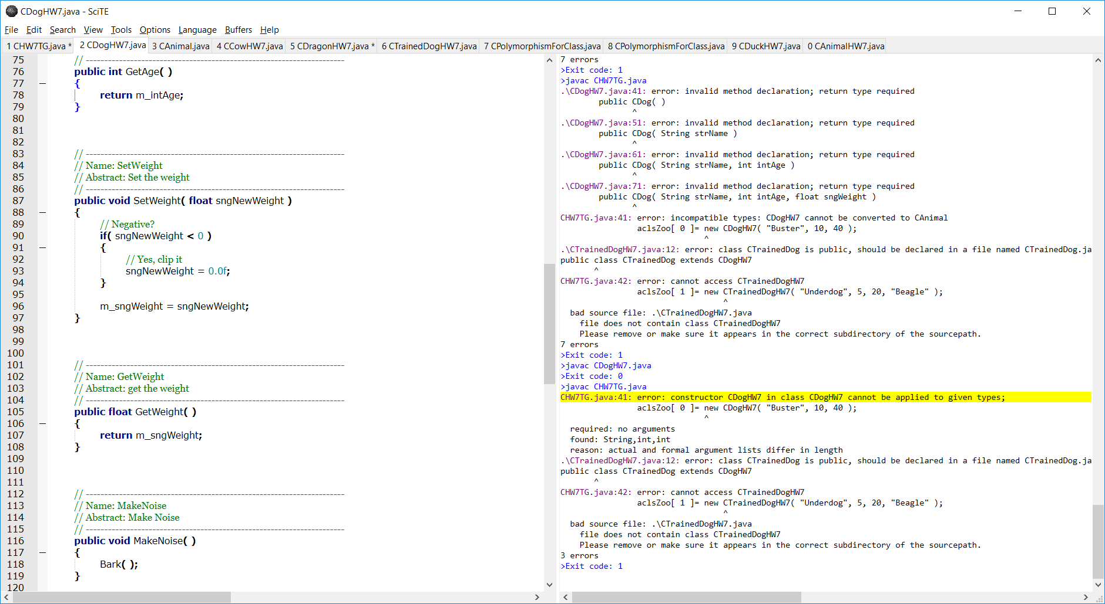

* Add SetAge/GetAge

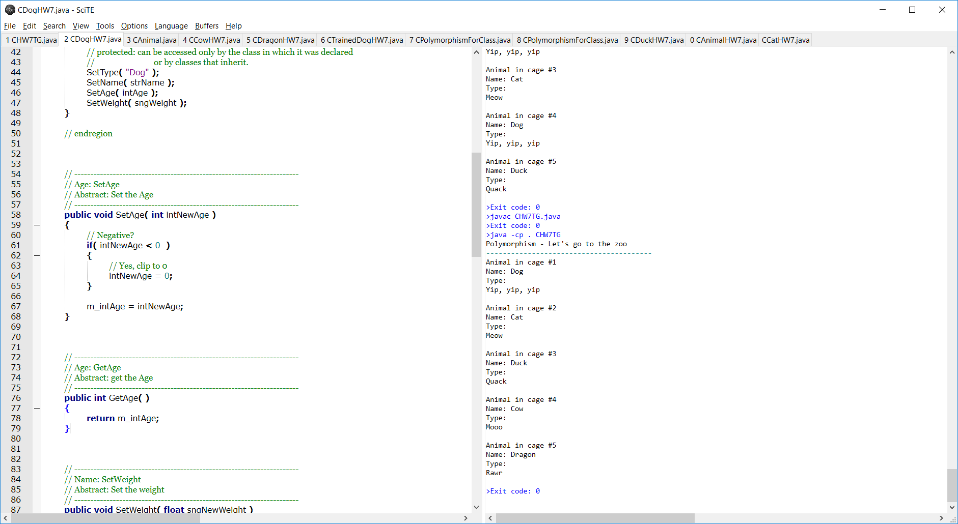

* Add a public MakeNoise method that call the Bark method.

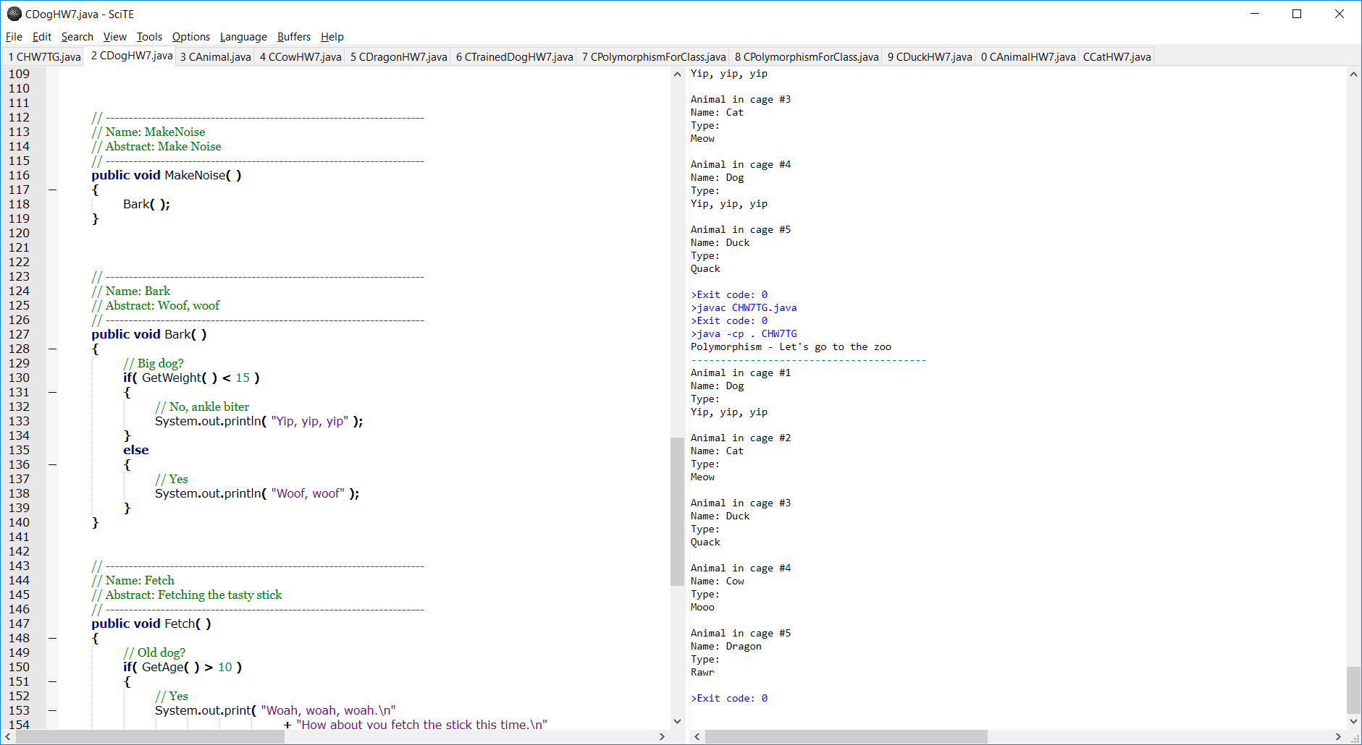

* Add a public Fetch method

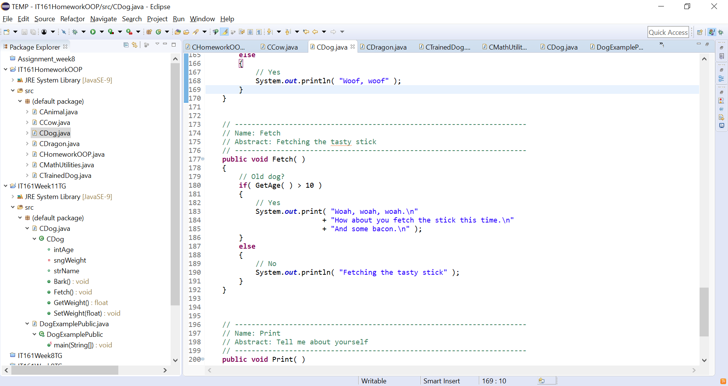

1. Make a CCat class.

* Inherit the CAnimal class.
* Create MakeNoise method to print “Meow”

1. Make a CDuck class.

* Inherit the CAnimal class.
* Create MakeNoise method to print “Quack”

1. Make a CCow class.

* Inherit the CAnimal class.
* Add at least one private property (e.g. color - **private** String m_strColor = "";) with public get/set methods. Include some sort of boundary checking in the set method.

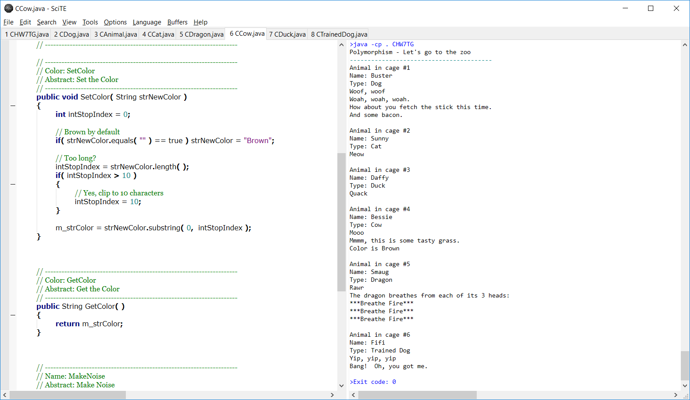

* Add at least one public, class specific method (e.g. Graze).

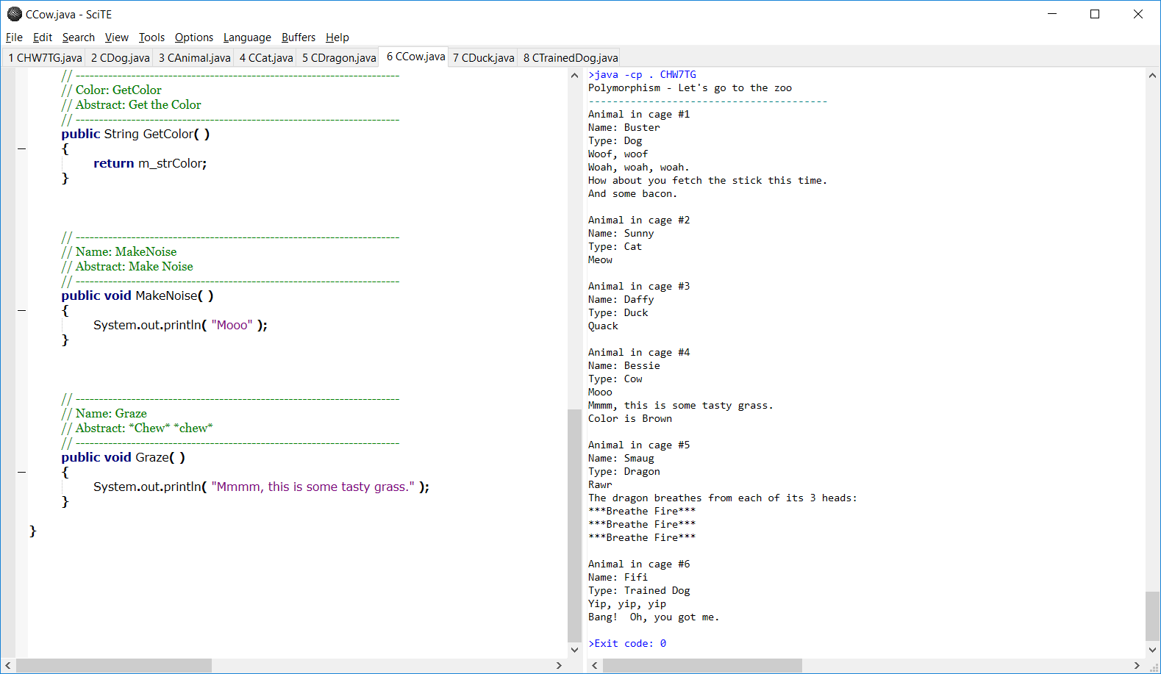

* Add a public MakeNoise method and print “Mooo” or something similar.



1. Make some other class (e.g. CDragon) class.

* Inherit the CAnimal class.
* Create one private property int m_intHeadCount (**private** **int** m_intHeadCount = 1;)and default it to 1.
* Add at least one private property (e.g. HeadCount) with public get/set methods. Include some sort of boundary checking in the set method.
* Add at least one public, class specific method (e.g. BreatheFire). Here is a sample:

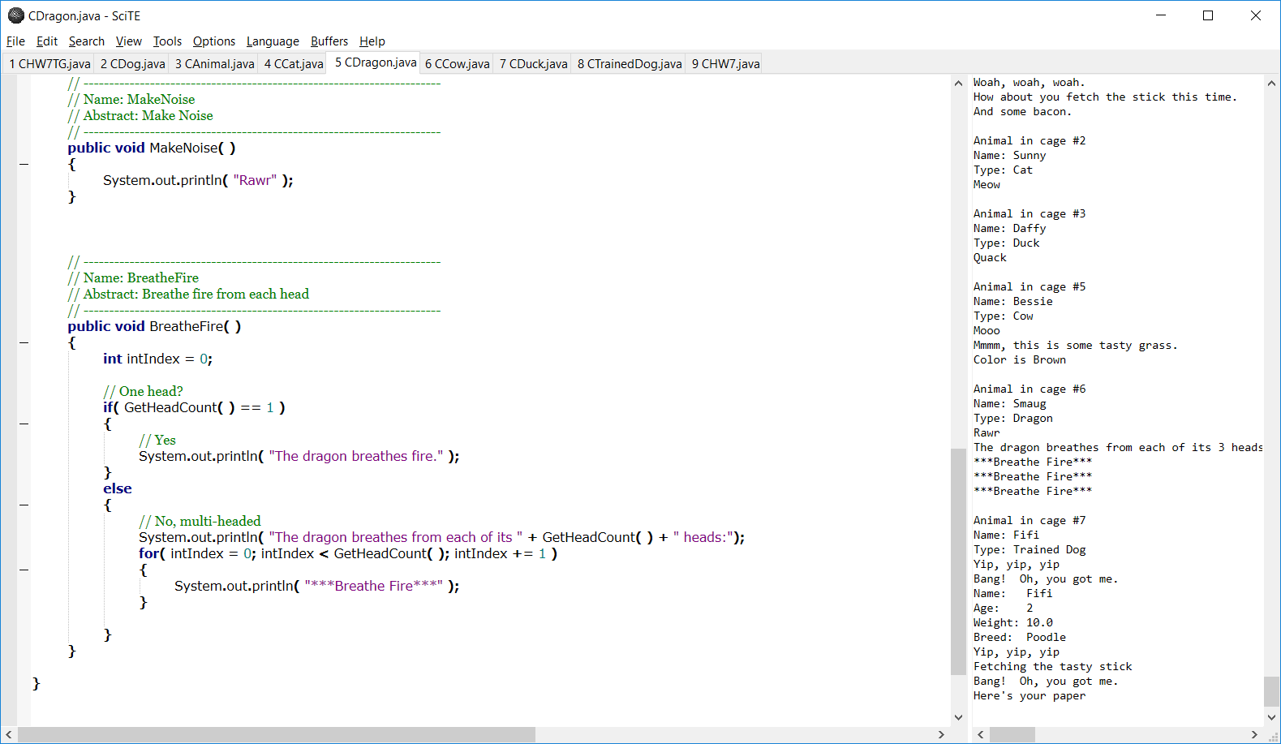

* Add a public MakeNoise method and print something appropriate for the animal.

1. Make some other class (e.g. CTrainedDog) class.

* Inherit the CDog class.
* Add at least one private property (e.g. breed - **private** String m_strBreed = "";) with public get/set methods. Include some sort of boundary checking in the set method – maximum 10 characters for the breed.

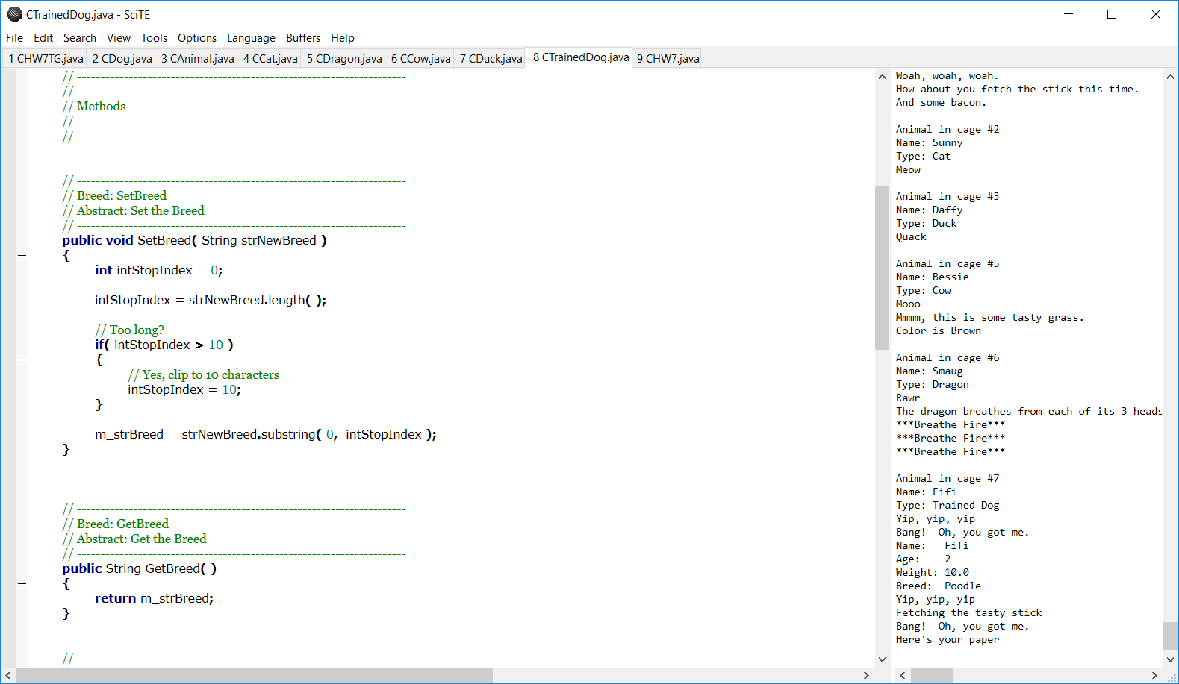

* Add at least one public, class specific method (e.g. PlayDead).
* Add a public FetchNewspaper – if the dog is under 2, print “I’m too young” else print “Here’s your paper”.

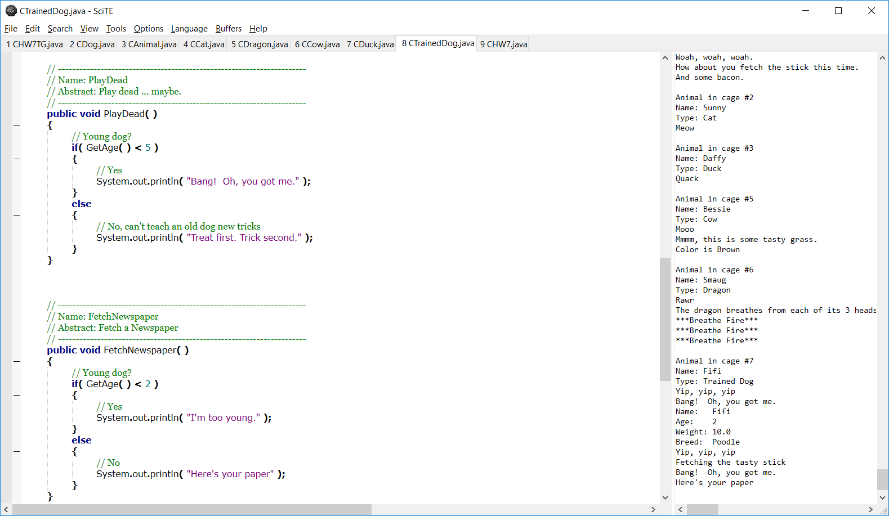

* Add a public Print in CTrainedDog.

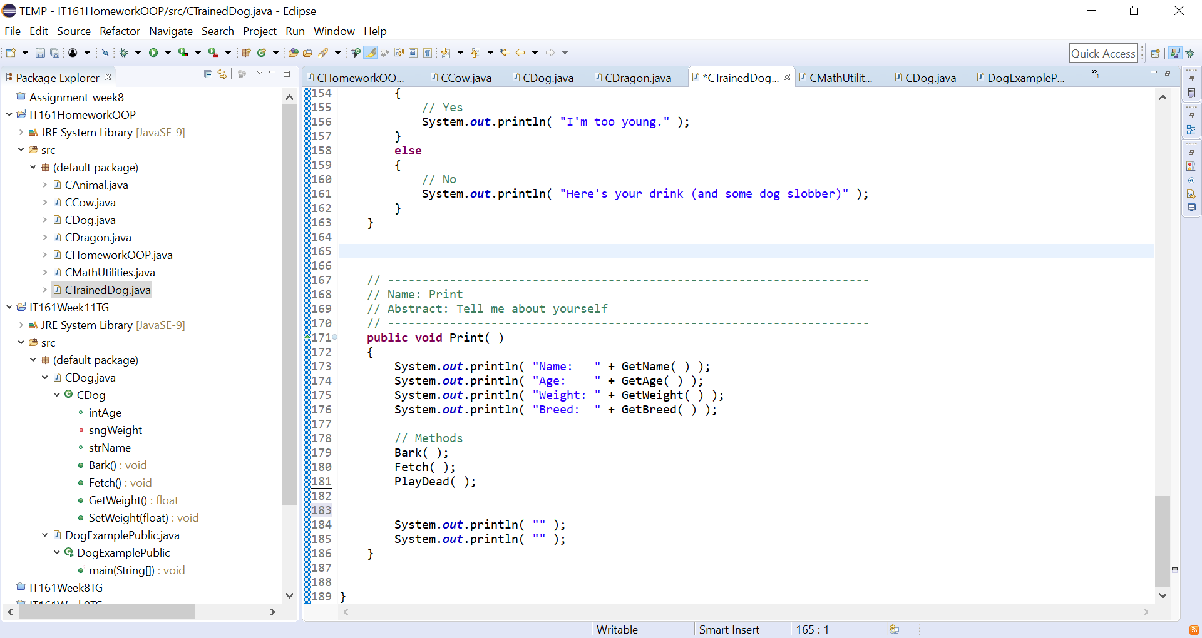

1. Make a ShowPolymorphism in CHomeworkOOP and call it from main.

* Make an array of type CAnimal and allocate space of at least size 7.
* Make at least one instance of all the animal classes (except for CAnimal) and assign them to the array. Leave at least on element in the array unassigned with a null value.
* Loop through the array elements and call GetName, GetType and MakeNoise for each non-null value.

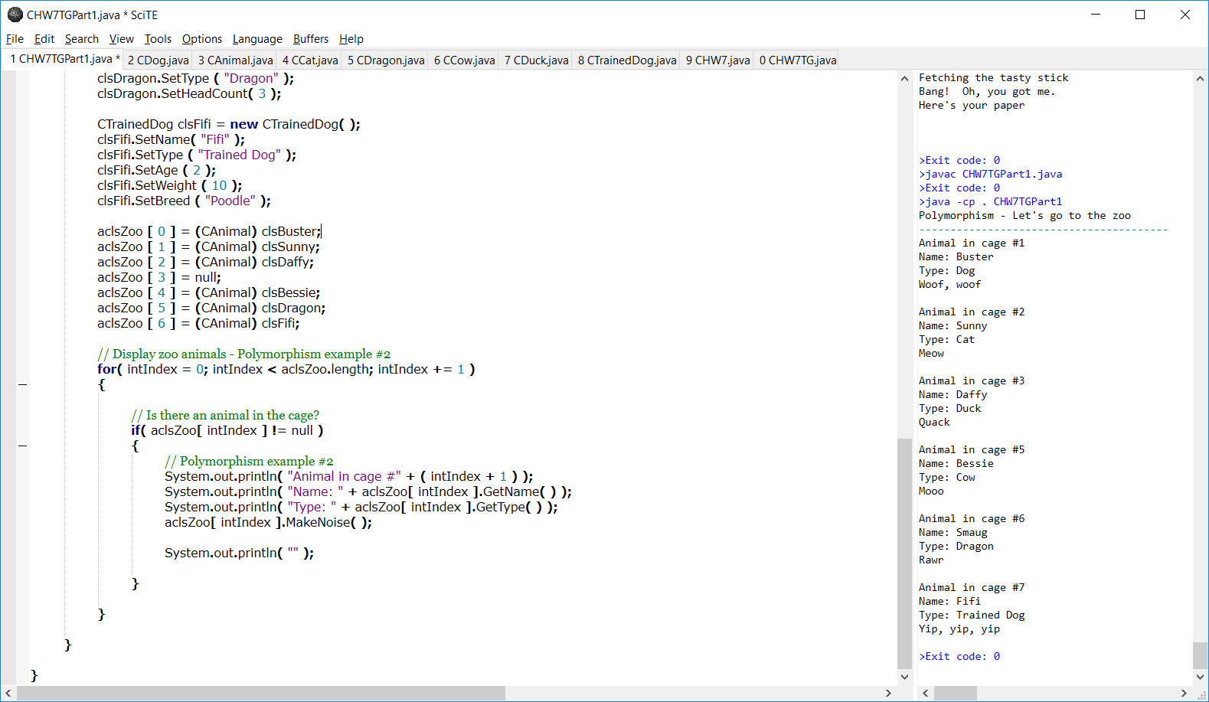

1. Modify the code inside the IF statement in the previous step. Add another IF/ELSE IF set of statements that check the animal type. Compare the animal type with the values you set in the initialize methods. If there’s a match do an explicit cast into the specific animal type and then call the child class specific method you created. For example:

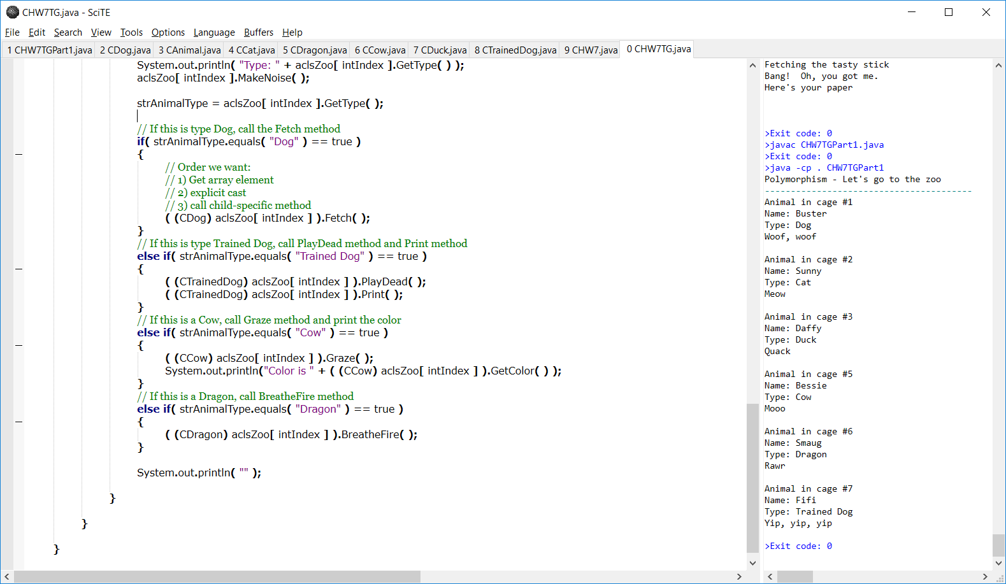

1. You have now successfully implemented polymorphism.

Here is a sample of my output:

